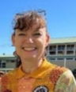

Hi my name is Louise and I have been associated with Benarrawa for several years through the Educators Learning Circle. I started my working career in the environmental field and after having 3 beautiful children I changed careers to the honourable teaching profession. I want to be the best I can be so I can help bring about a more just and equitable Australia. It starts with my colleagues. Education is the key.

