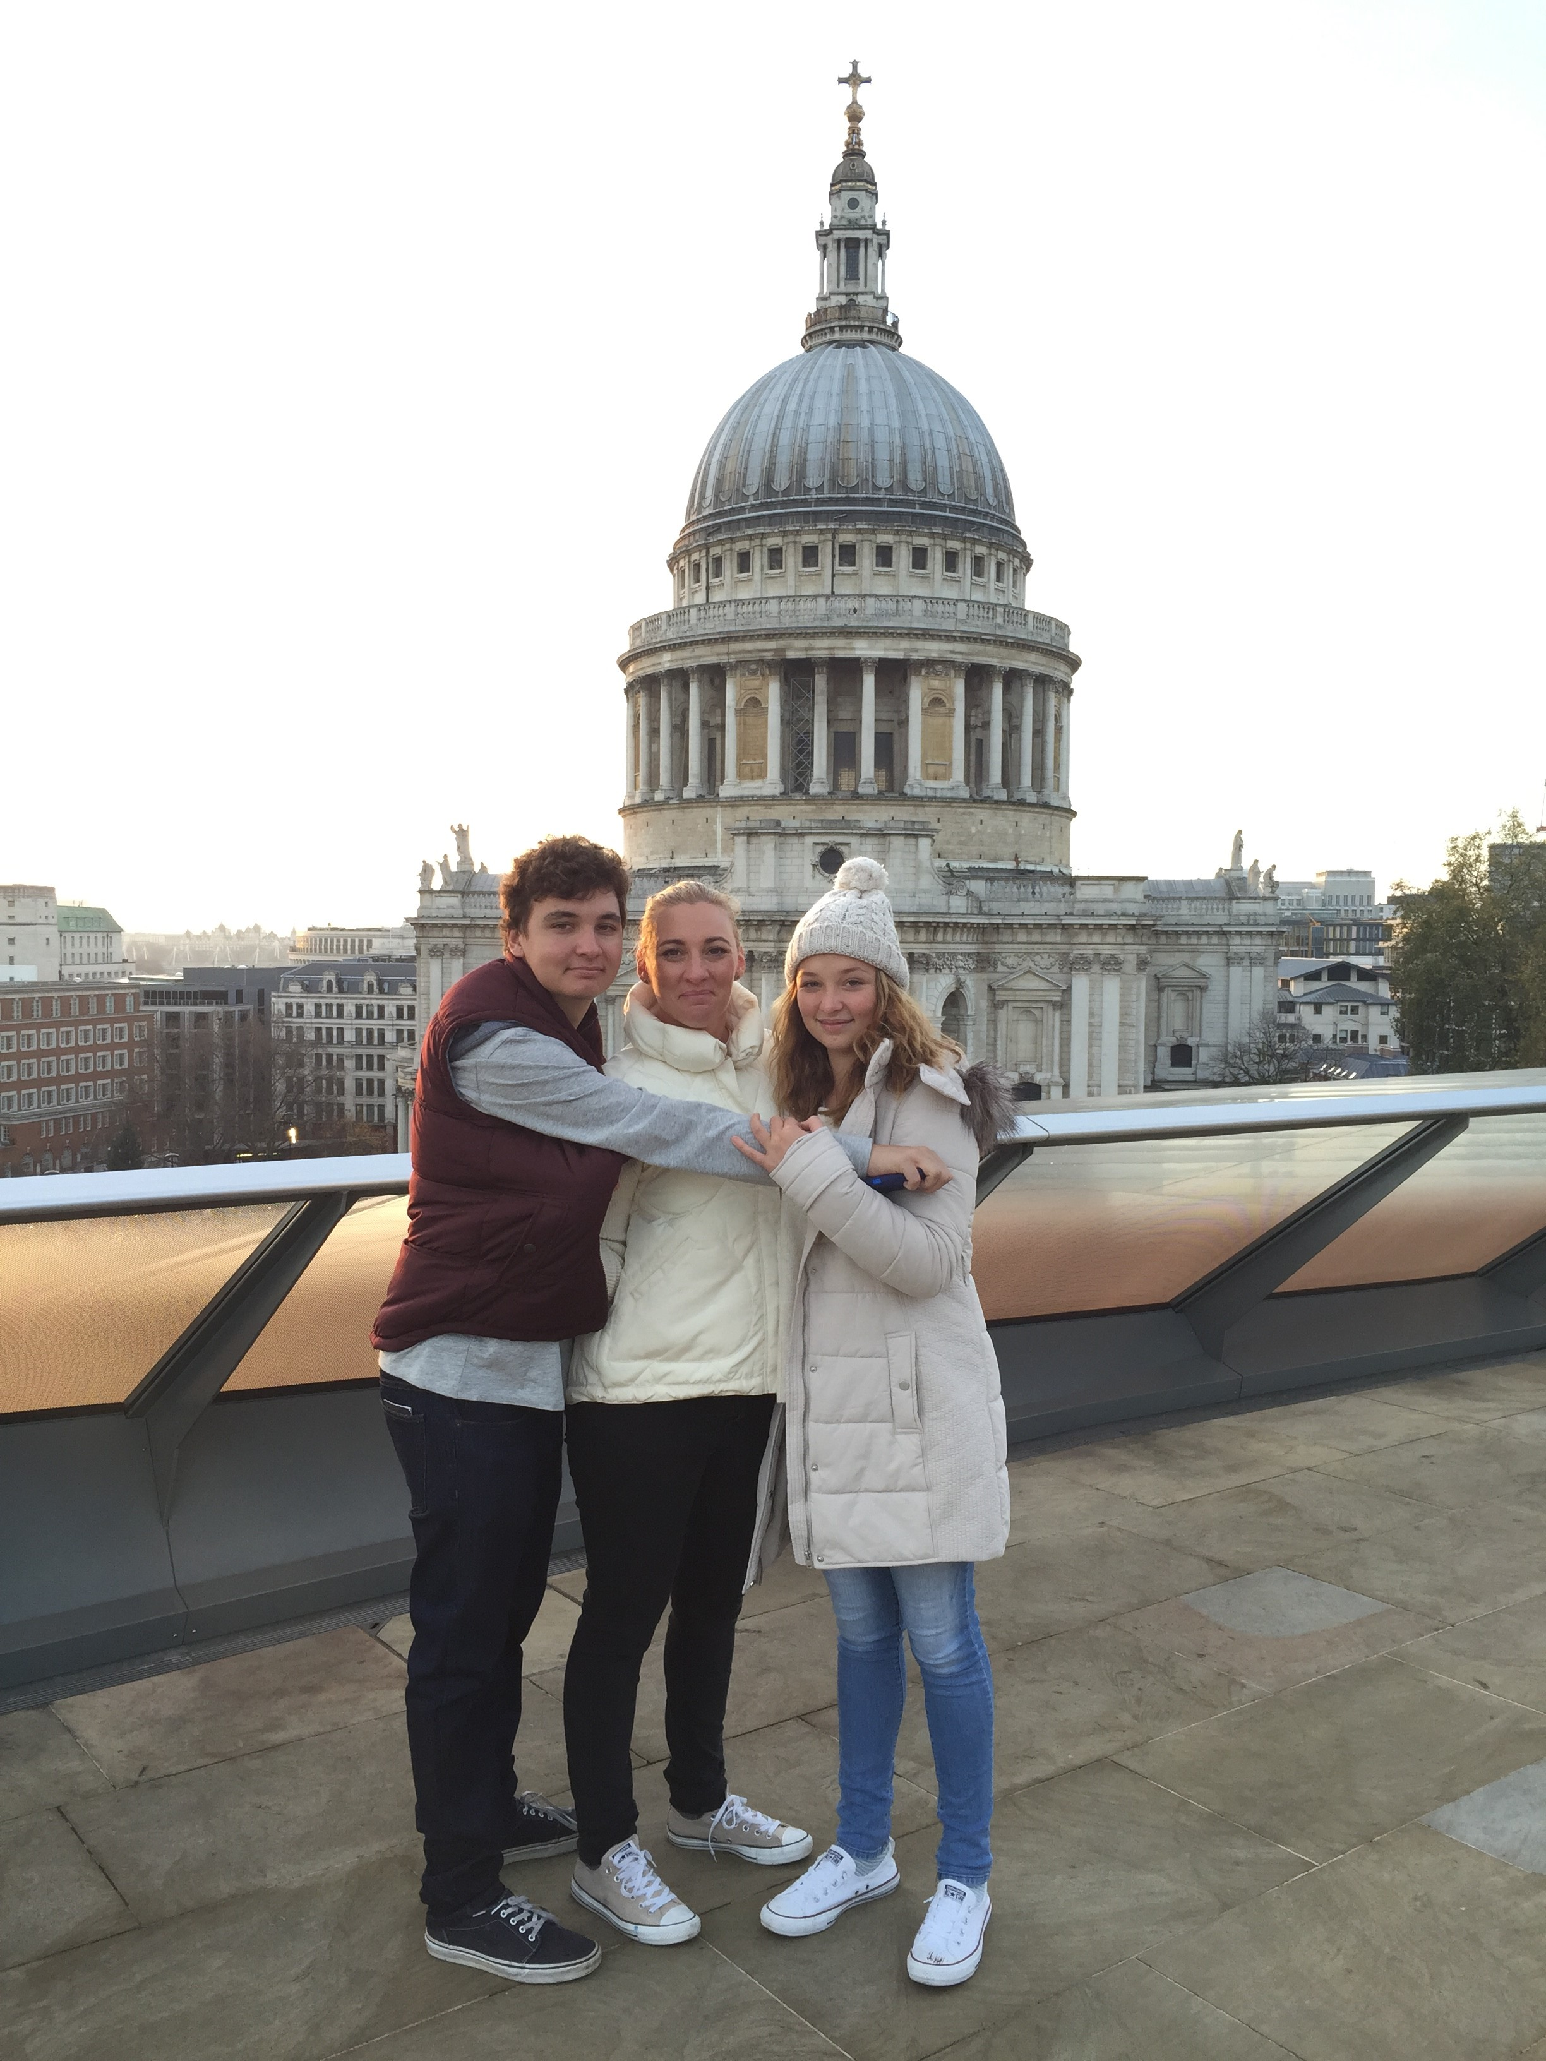
I am Jane and I live on Yagara Country (Ipswich). I have been in education for 28 years and I love my job, working with young people makes me happy. I have had a number of different roles and worked in different settings and different locations, currently I am QASMT in Toowong and work in the Inclusion and Wellbeing space.
In the photo are my two beautiful children now adults with whom I love with my whole heart. Gardening, working on my little old queenslander, my animals and travel are what I like to do.
Benarrawa was introduced to me by a teaching colleague as I wanted to learn more about how I can support First Nations students. I then joined the committee and I am looking forward to the connection. In truth though it is more than that. My children’s grandmother on their father’s side was a First Nations woman who kept her identity a secret from her whole family and they only learnt about it after her passing, she was a part of the stolen generation. As is my mother’s half-sister, Aunty Judy. And my niece Angel is also a first nations woman.
I want to learn about culture and connection, and I want to be able to share what I learn.

